**CS 131C# - Beginner**

**HOP06 – String Manipulation**

02/11/2019 Developed by Kim Nguyen

Center for Information Assurance (CIAE) @City University of Seattle (CityU)



**Before You Start**

* Version numbers may not match with the most current version at the time of writing. If given the option to choose between stable release (long-term support) or most recent, please choose the stable release rather than beta-testing version.
* This tutorial targets Windows users and MacOS users.
* There might be subtle discrepancies along the steps. Please use your best judgement while going through this cookbook style tutorial to complete each step.
* For your working directory, use your course number. This tutorial may use a different course number as an example.
* The directory path shown in screenshots may be different from yours.
* If you are not sure what to do or confused with any steps:
  1. Consult the resources listed below.
  2. If you cannot solve the problem after a few tries, ask a TA for help.

**Learning Outcomes**

Students will be able to:

* Understand strings.
* Manipulate strings.
* Use string manipulations into programs.

**Resources**

* C# Tutorial | Freecodecamp.org- <https://youtu.be/GhQdlIFylQ8>
* C# Tutorials | W3Schools.com- <https://www.w3schools.com/cs/default.asp>
* C# Tutorials | tutorials.com- [https://www.tutorialspoint.com/csharp/](https://www.tutorialspoint.com/csharp/csharp_strings.htm)

Strings are used for storing text. A string variable contains a collection of characters surrounded by double quotes. For example:

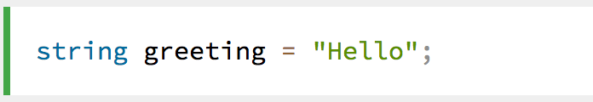

In C#, you can use strings as array of characters, However, more common practice is to use the string keyword to declare a string variable.

**Create a project**

1. Open Visual Studio.
2. File > New > Project
3. Select Console App (.NET Core), click Next
4. Type “String” in the Project name and save it in the following locations:

**If you are an online student:**

Save it here > CS131-Spring-2020\**ON**\FirstnameLastname/Module6/String-Manipulation

**If you are an onsite student:**

Save it here > CS131-Spring-2020\**IN**\FirstnameLastname/Module6/String- Manipulation

**String Concatenation**

In previous HOPs, we have learned to perform calculations using arithmetic operators (+ - / * %), this week, let's explore another function of arithmetic operators on strings.

1) Type the following in your Program.cs

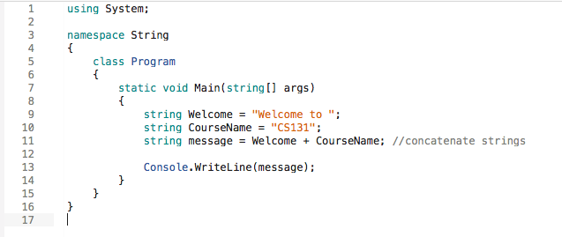

We can combine two or more strings together, this is called "String Concatenation"

2) Run your program to see the output:

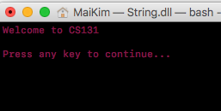

Besides using arithmetic operators to concatenate strings, let's try to do so using different methods.

3) Update your code to match the following screenshot:

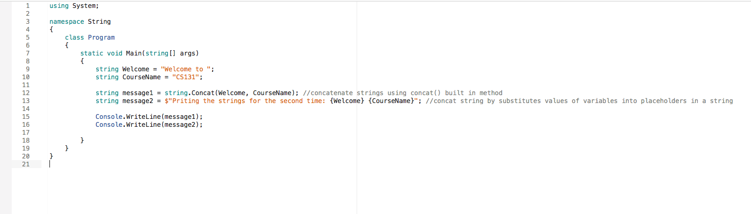

4) Run your Program.cs to see the result:

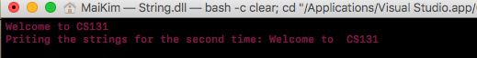

**Other Methods:**

5) Now, let's play some more with strings. Update your code to match the following screenshot (line 11):

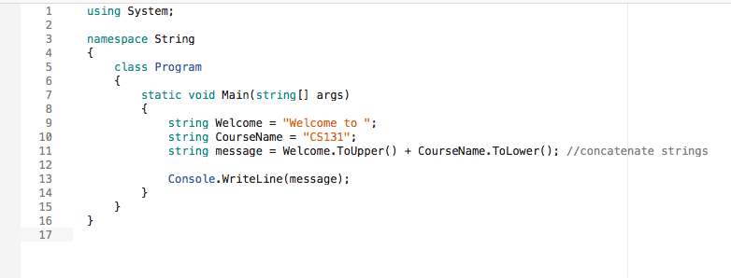

6) Run the program again to see:

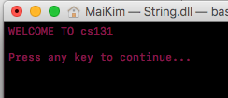

We have converted the string "Welcome to" to all upper cases, and string "CS131" to lower cases. This action was done using ToUpp() and ToLower() built in methods in C#. There are other built in methods that can be applied for strings, feel free to explore around!

There are other things manipulations that are useful for string.

**Get String Length**

7) Update your code to match the following screenshot:

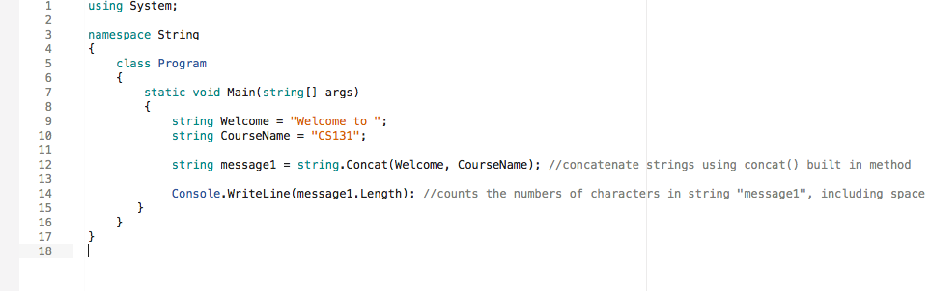

8) Run your program to see:

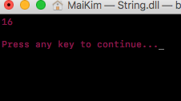

Get String Index or Value

9) Update your code to match the following screenshot:

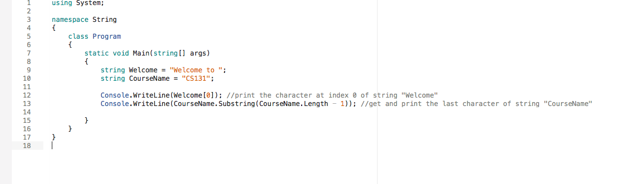

10) Run your Program.cs, you should see the first character of string "Welcome" and last character of string "CourseName" printed:

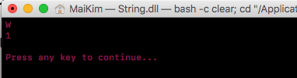

11) Let's write a program that's more fun. What if I want to print out each character of a string individually? Let's write a loop that prints out each character of a string. Update your code to match the following screenshot:

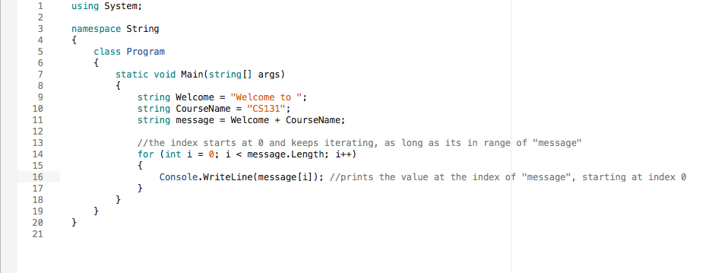

12) Run your code:

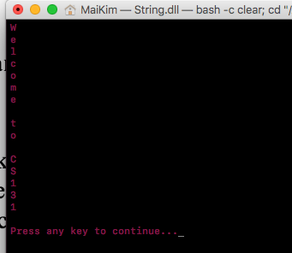

**CHALLENGE:**

Print all the character at even index of string "message". Expected output:

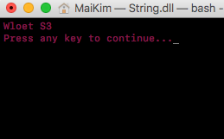

Hint: use %

**Push your work to GitHub**

**Commit changes**

1. Click on the **Home** button > **Changes**
2. Type commit message
3. Select **Commit All and Push**

**Create a pull request**

1. Go to your fork page on GitHub website
2. Near the top left side, change the active branch to your new branch
3. Click on the "New Pull Request" button next to the branch name.